**Tableau Assignment Project 1:**

This assignment is based on Travel data that is recorded by the driver when he travels back and forth to his office and home. I have analysed the data, based on the graphical visualisations in Tableau.

**Insight 1:**

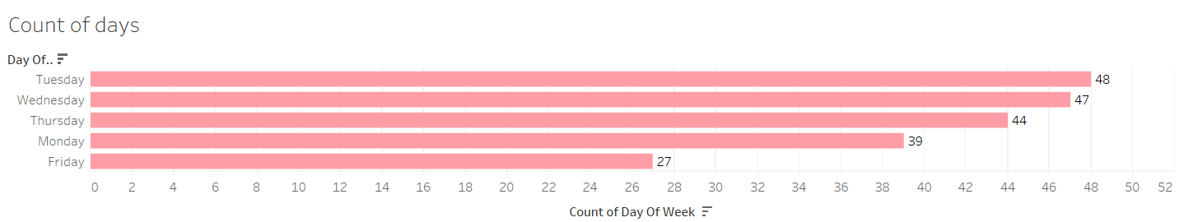

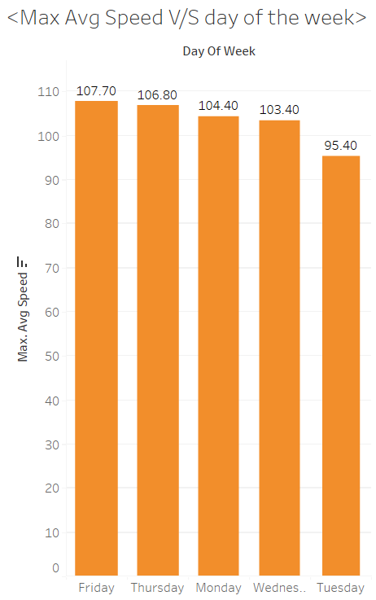

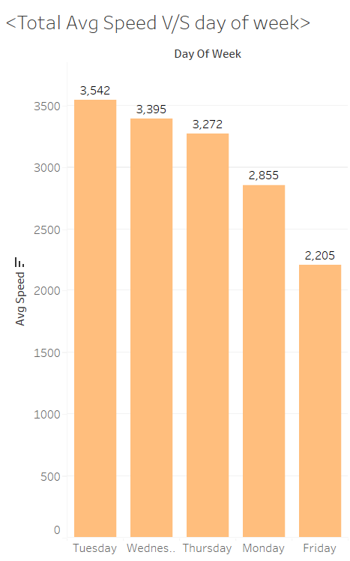

From the above graphs, it can be inferred that the maximum number of trips have occurred on Tuesday. The total average speed on Tuesday is highest but the maximum average speed on Tuesday is lowest. The maximum average speed on Friday is highest whereas the number of trips on Friday is lowest.

**Insight 2:**

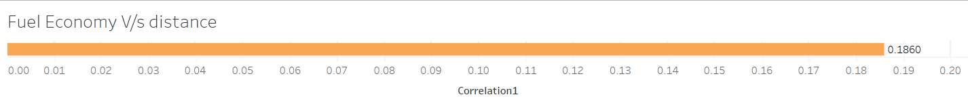There is a slight positive correlation between distance and fuel economy.

There is a slight negative correlation between average moving speed and fuel economy.

There is a slight negative correlation between average speed and fuel economy.

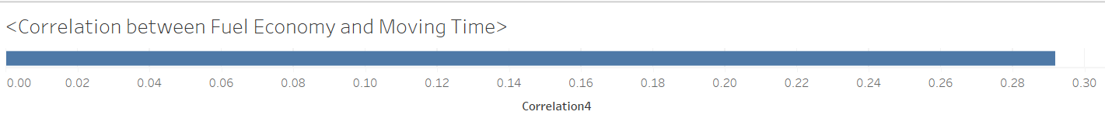

There is little positive correlation between moving time and fuel economy.

From the above three correlation graphs, it can be inferred that there is very low correlation between fuel economy and average speed, average moving speed, distance, and moving time.

**Insight 3:**

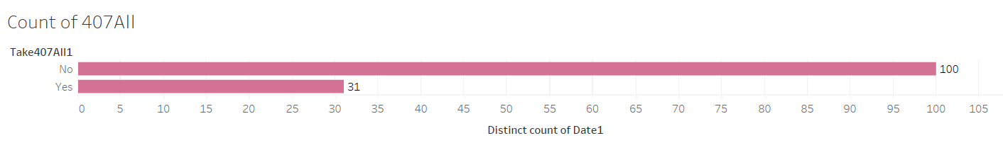

The above graph shows that the driver does not take 407ALL route on maximum number of days.

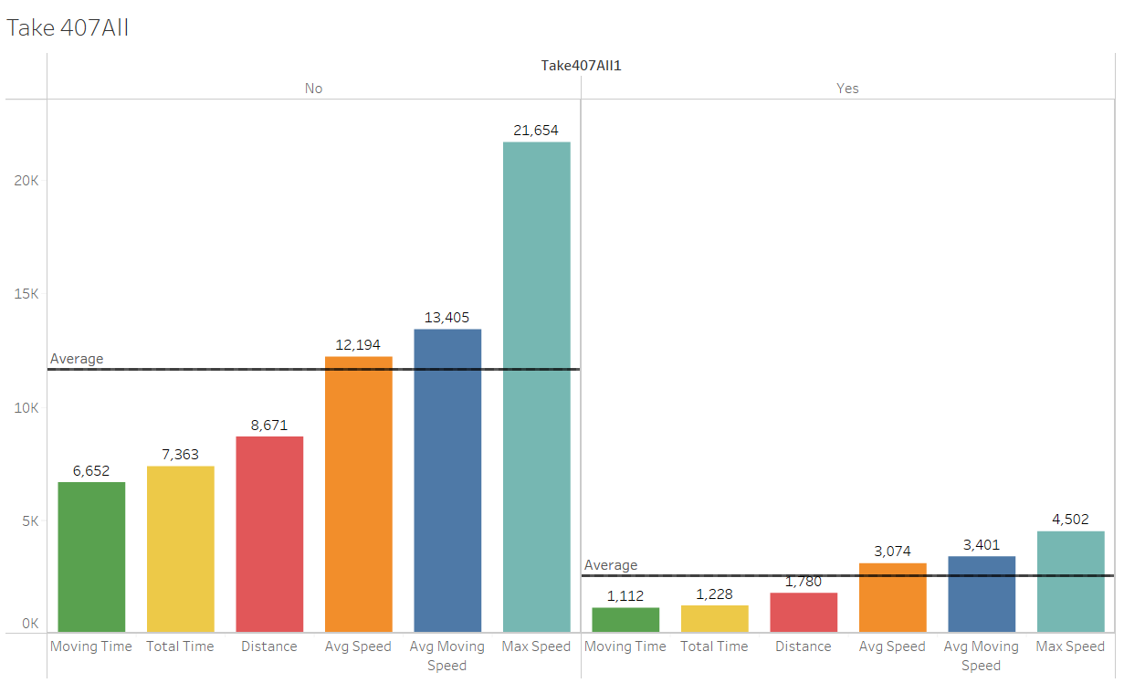

The above graph shows that the moving time, total time, distance, average speed, average moving speed and total maximum speed are much higher when the driver does not take 407ALL route, since the number of trips on other routes are much more in number than the ones on this route.

**Insight 4:**

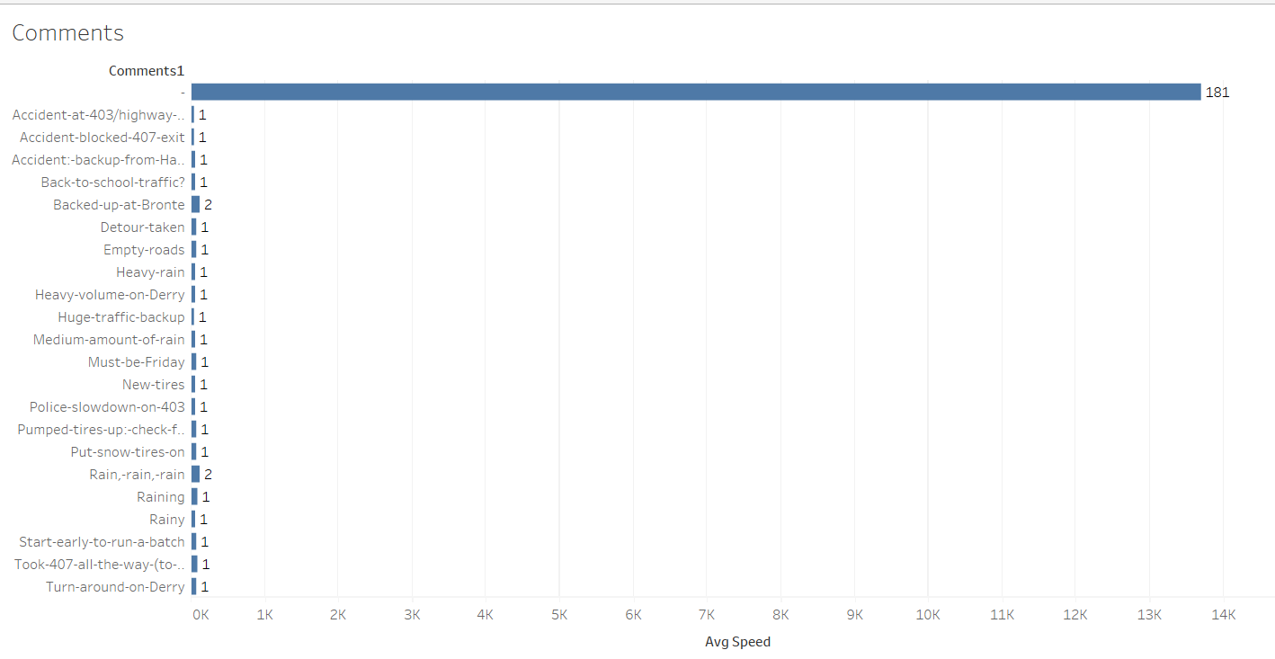

The above graph shows that for maximum number of entries, the comments are blank. There are very few accidents.

**Insight 5:**

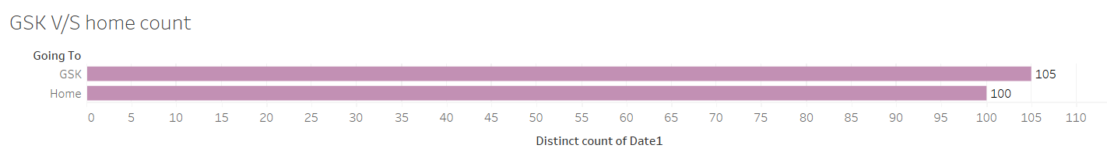

The total number of trips to GSK i.e., workplace is marginally more than the total number of trips to home.

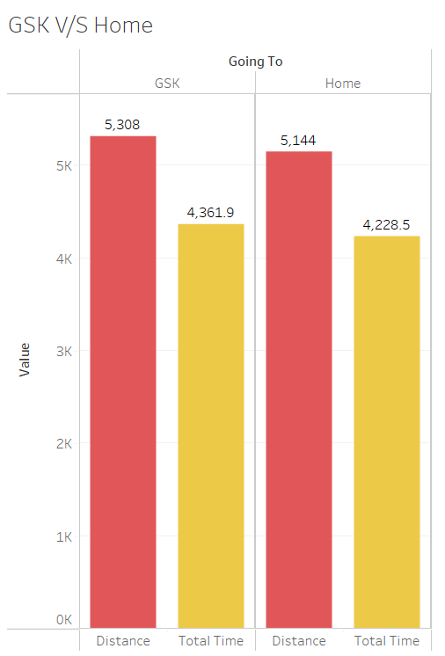

Total distance and total time taken to reach the office GSK is also marginally more than that required to reach home.

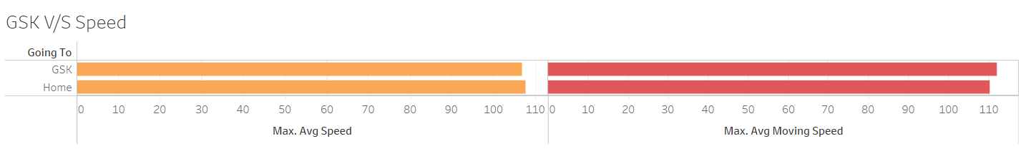

The maximum speed is almost same for both the destinations i.e., home and office.

**Insight 6:**

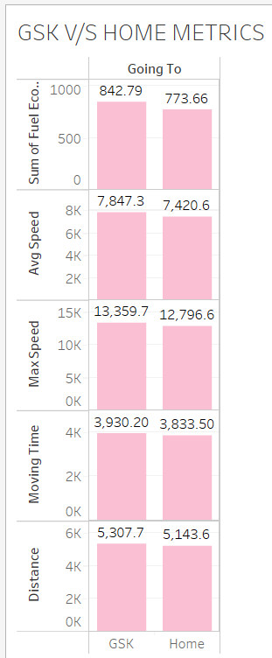

The total economy, average speed, max speed, moving time, and total distance are slightly higher while going to GSK than while going home.

**Dashboard 1:**

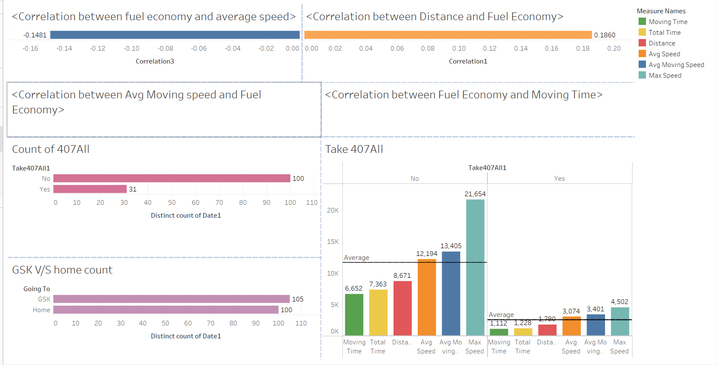

**Dashboard 2:**

